ENGINEER 1C03 - Engineering Design & Graphics

Engineering 1 Cornerstone Design Project

Instructor: Dr. Nease

**Technical Report**

Team **13**

Lab Section**: L03**

Vineeth Balachandran – balacv1 – 400238031

Yuntian Wang – wangy716 – 400234676

Tianze Zhang – zhant22 – 400208135

Jinnan Cheng – chengj64 – 400226963

As a future member of the engineering profession, the student is responsible for performing the required work in an honest manner, without plagiarism and cheating. Submitting this work with my name and student number is a statement and understanding that this work is my own and adheres to the Academic Integrity Policy of McMaster University and the Code of Conduct of the Professional Engineers of Ontario.

Submitted by [Vineeth Balachandran, 400238031]

Signature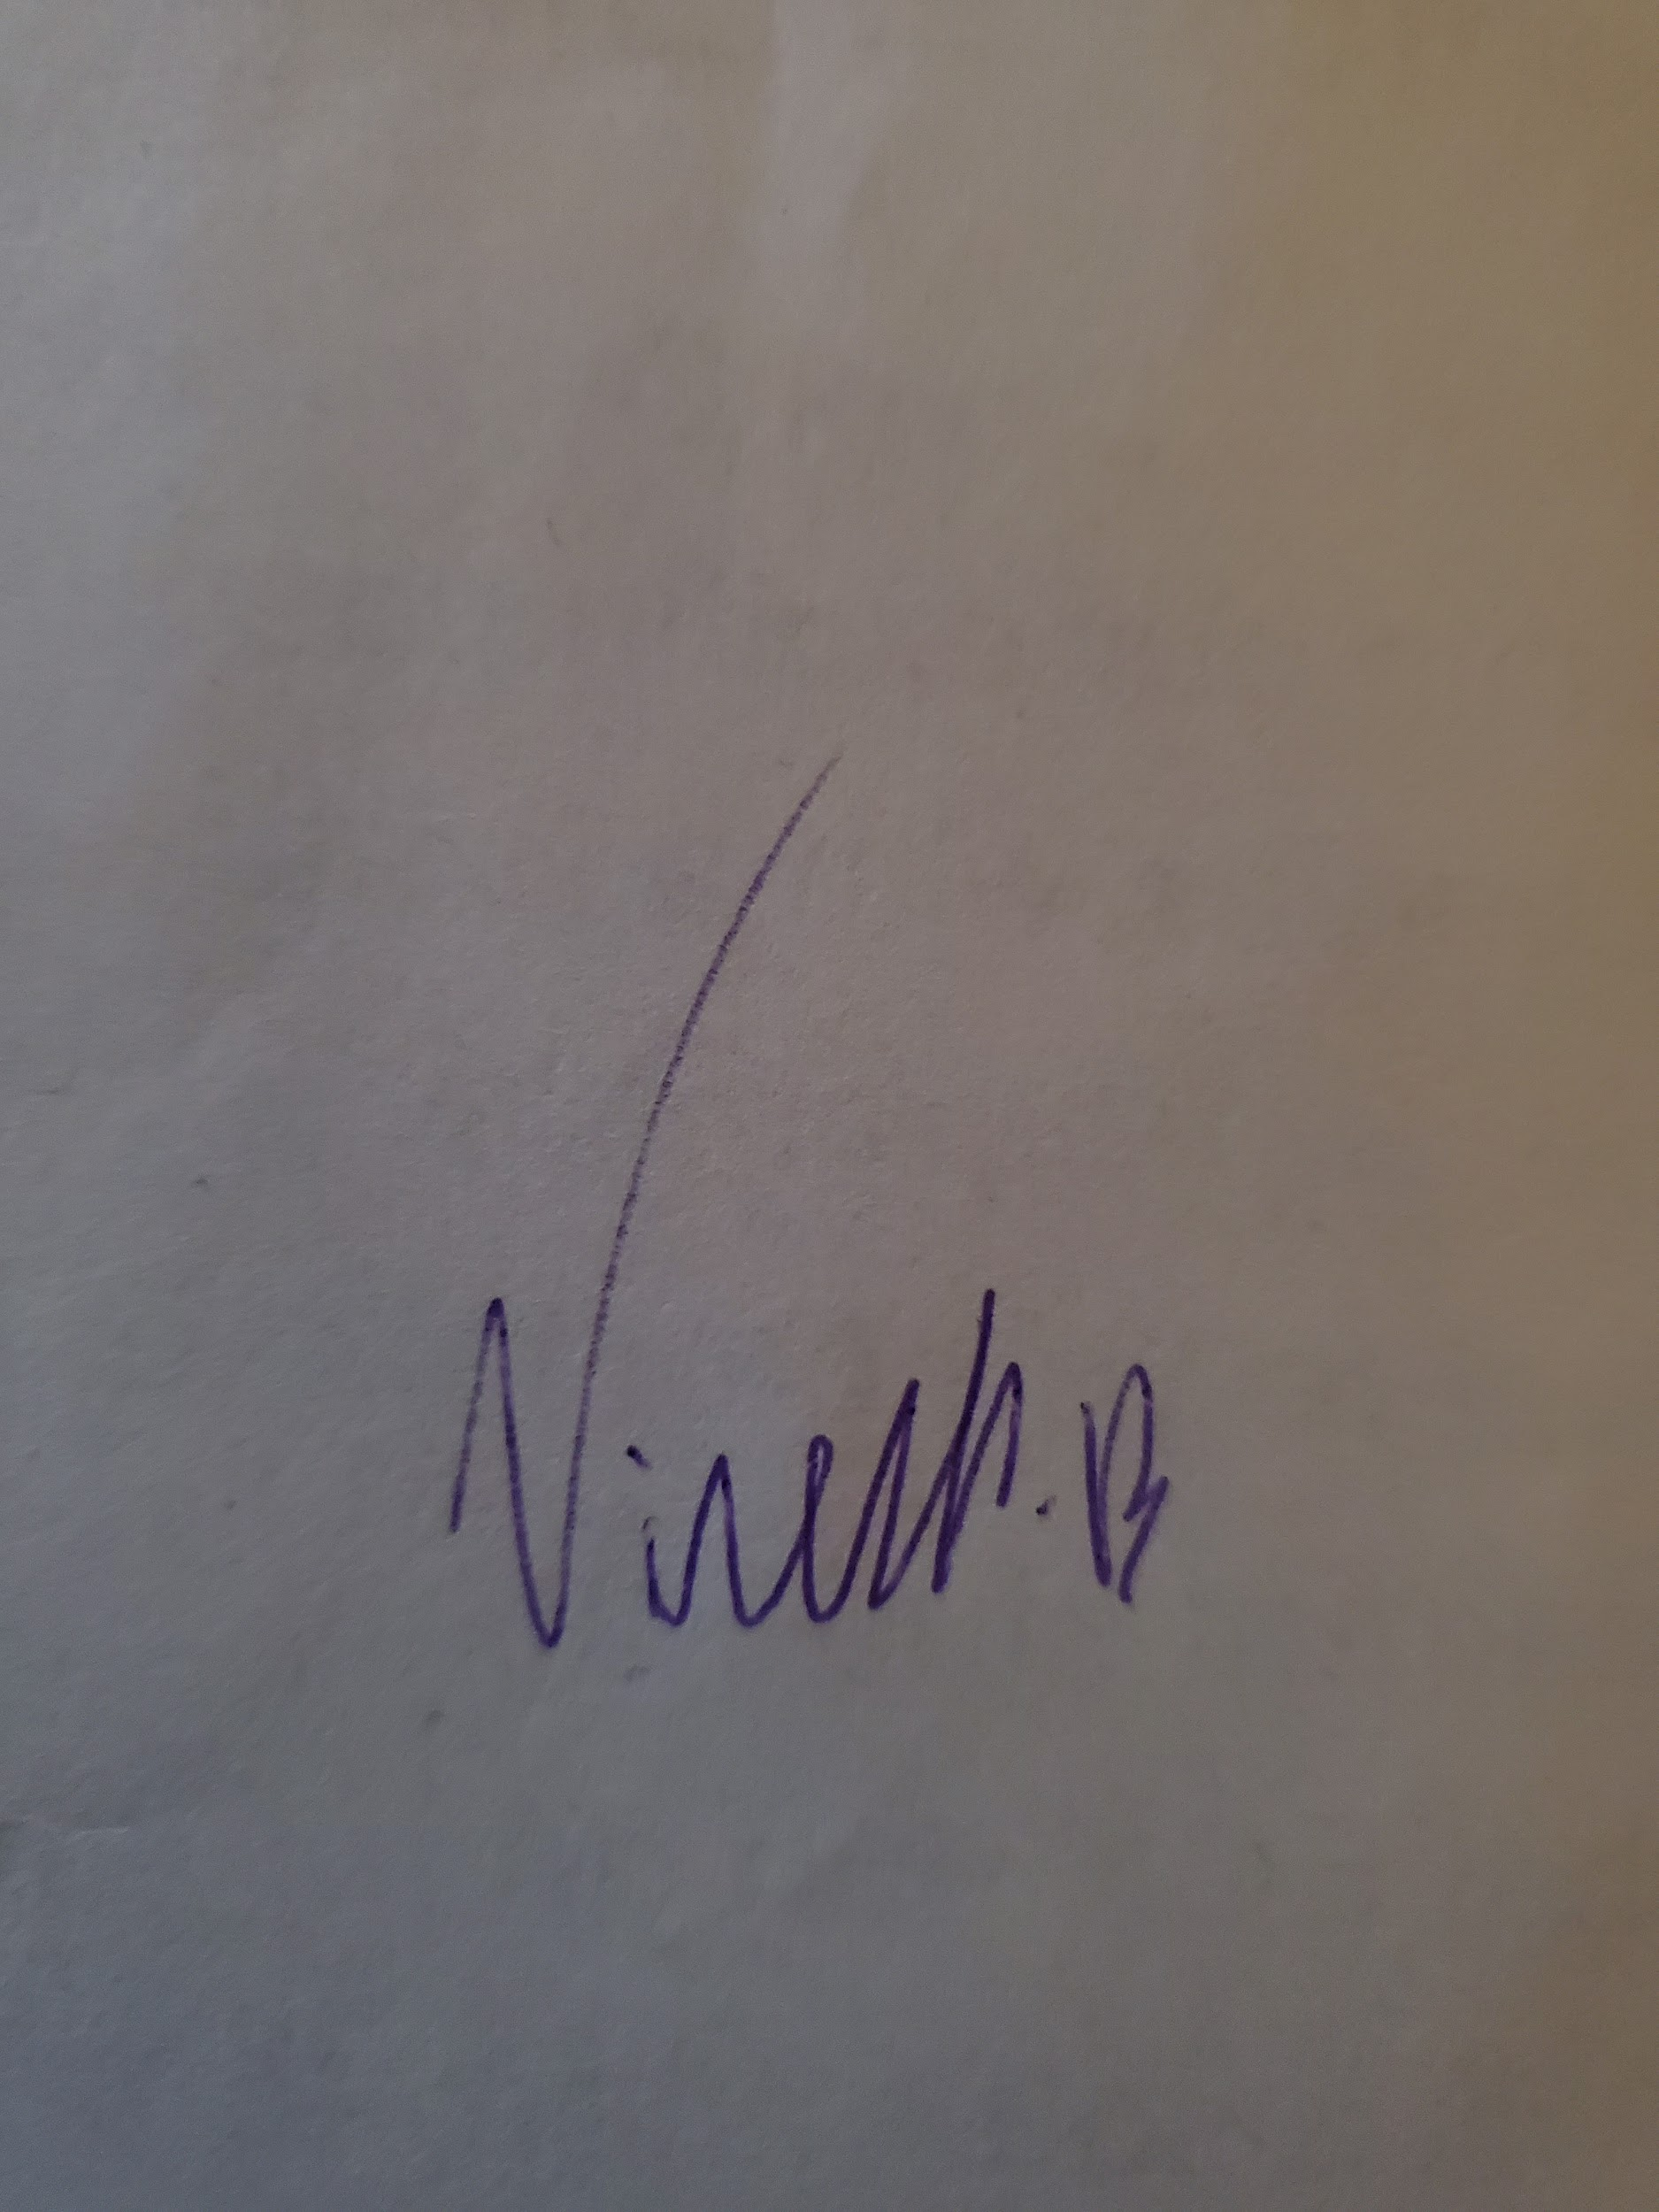

As a future member of the engineering profession, the student is responsible for performing the required work in an honest manner, without plagiarism and cheating. Submitting this work with my name and student number is a statement and understanding that this work is my own and adheres to the Academic Integrity Policy of McMaster University and the Code of Conduct of the Professional Engineers of Ontario.

Submitted by [Yuntian Wang, 400234676]

Signature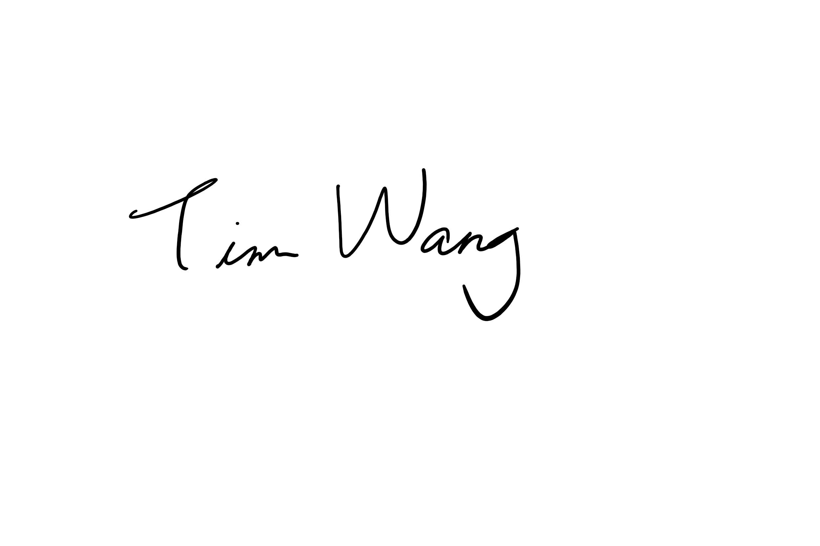

As a future member of the engineering profession, the student is responsible for performing the required work in an honest manner, without plagiarism and cheating. Submitting this work with my name and student number is a statement and understanding that this work is my own and adheres to the Academic Integrity Policy of McMaster University and the Code of Conduct of the Professional Engineers of Ontario.

Submitted by [Tianze Zhang, 400208135]

Signature 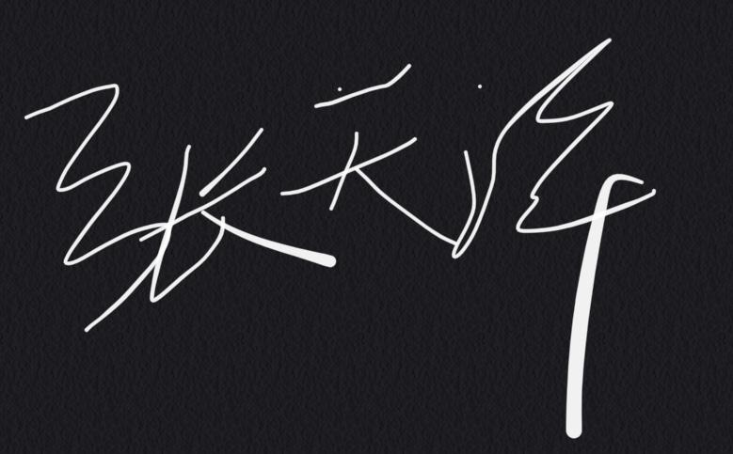

As a future member of the engineering profession, the student is responsible for performing the required work in an honest manner, without plagiarism and cheating. Submitting this work with my name and student number is a statement and understanding that this work is my own and adheres to the Academic Integrity Policy of McMaster University and the Code of Conduct of the Professional Engineers of Ontario.

Submitted by [Jinnan Cheng, 400226963]

Signature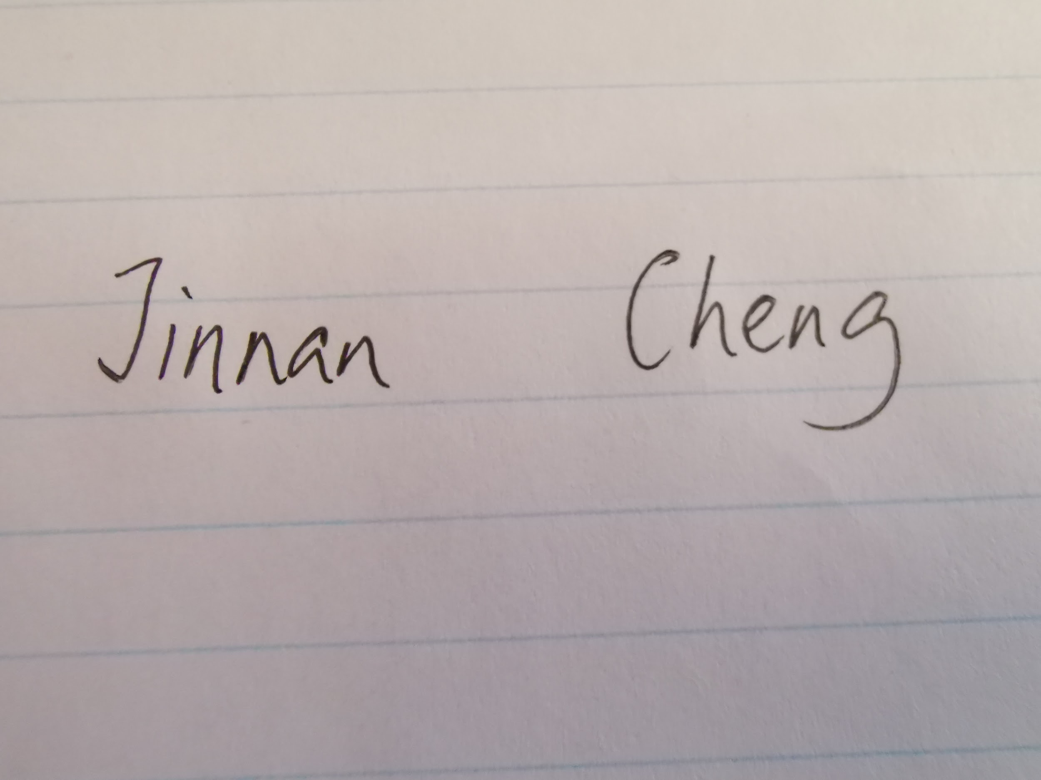

# Table of Contents

1. Introduction…………………………………………………………………………....4
   1. Brief Description of Design…………………………………………………...4
   2. Overview of Report……………………………………………………………4
2. Calculations…………………………………………………………………………....4
3. Mechanism Design Parameters………………………………………………………..5
4. Simplified Gearing Mechanism Diagrams…………………………………………….6
5. Assembly Views……………………………………………………………………….8
6. Inventors Dynamic Simulation Graphs………………………………………………..9
7. Challenges and Explanation of the Prototype Design……………...….……………..11
8. Unique Features………………………………………………………..…….……….14
9. Answers to Group Discussion Questions…………………………………………….14
10. Summary of Individual Contributions………………………………………………..16
11. Summary of Member Attendance………………………………………..…………..17
12. Gantt Chart…………………………………………………………………………...17
13. References……………………………………………………………………………17

# 1. Introduction

This 1C03 project acquires our team to design a set of gears and mounting brackets that can be fit within a provided prosthetic frame without any centers of gears exceeding the horizontal plane of the frame. Specific input and output angular speeds are also given as 109 rpm and 0.25 rps, respectively. Our gears are to be connected to a thumb and an index finger whose rotational motions are to be opposite to each other and both 0.25 rps in angular speed.

## 1.1 Brief Description of Design

In our final design, there are eight spur gears, including two gears with extruding finger features. Three groups of gears are connected axially with each other. Center axials of gears are not on the same horizontal plane, but their vertical distances relative to the prosthetic frame are all within constraints.

## 1.2 Overview of Report

In this technical report, assembly diagrams and screenshots, gear parameters, dynamic simulation graphs are covered,as well as hand calculations for the gear train design. There are also explanations of design, including challenges we met and unique features in the design, and answers to the group discussion questions. Near the end of the report, there are summaries of contributions by each team member to the project and member attendance with a gantt chart outlining all scheduled task dates.

# 2. Calculations

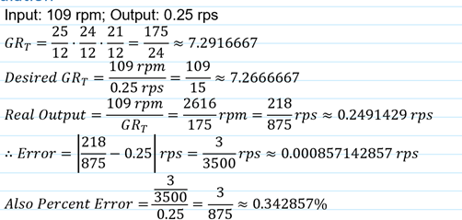

Fig. 1. Hand Calculations

# 3. Mechanism Design Parameters

TABLE Ⅰ

MECHANISM DESIGN PARAMETERS

| Gear Name | Type of Gear | Connection to Preceding Gear | | Pitch Diameter (mm), D | Module (mm/tooth), m | Number of Teeth, z | Face Width (mm) |
| --- | --- | --- | --- | --- | --- | --- | --- |
| Type | Name |
| A | Spur | N/A | N/A | 17.76 | 1.48 | 12 | 13 |
| B | Spur | mesh | A | 37 | 1.48 | 25 | 13 |
| C | Spur | axial | B | 16.8 | 1.4 | 12 | 13 |
| D | Spur | mesh | C | 33.6 | 1.4 | 24 | 13 |
| E | Spur | axial | D | 18.276 | 1.523 | 12 | 15.675 |
| F | Spur | mesh | E | 24.368 | 1.523 | 16 | 5 |
| G1 | Spur | mesh | F | 31.983 | 1.523 | 21 | 5 |
| G2 | Spur | mesh | E | 31.983 | 1.523 | 21 | 5 |

# 

# 4. Simplified Gearing Mechanism Diagrams

Fig. 2. Simplified Gear Mechanism Diagrams

Fig. 3. Additional Inventor Drawing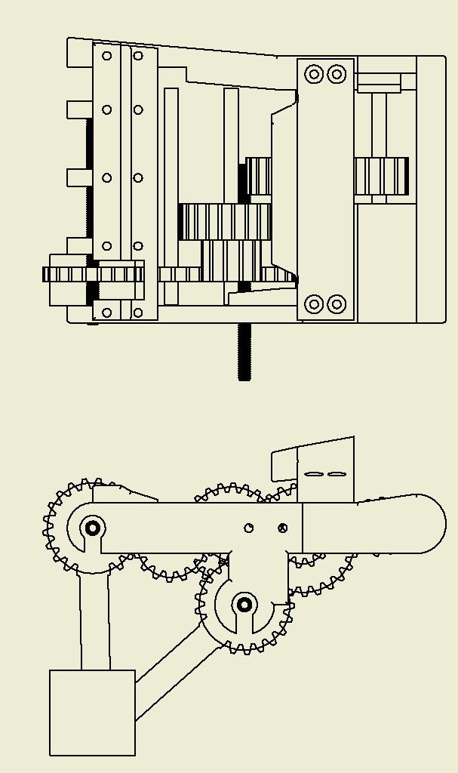

# 5. Assembly Views

Fig. 4. Screenshot of the Inventor Model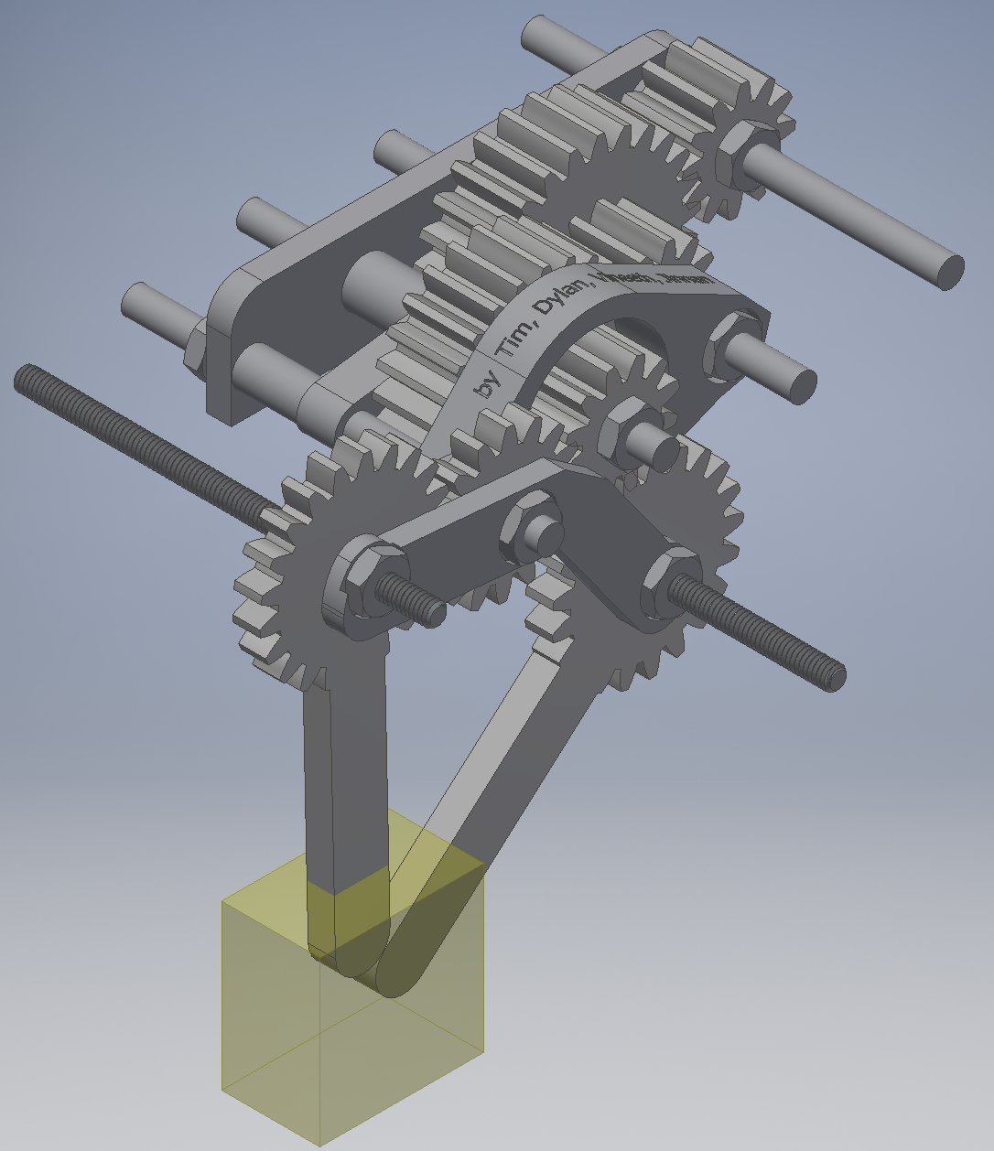

# 6. Inventors Dynamic Simulation Graphs

Fig. 5. Input Angular Velocity Graph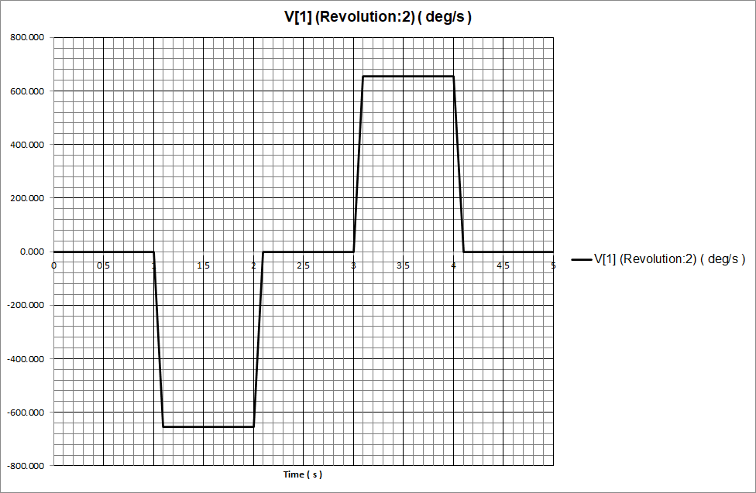

Fig. 6. Output Angular Velocity Graph of Gear G1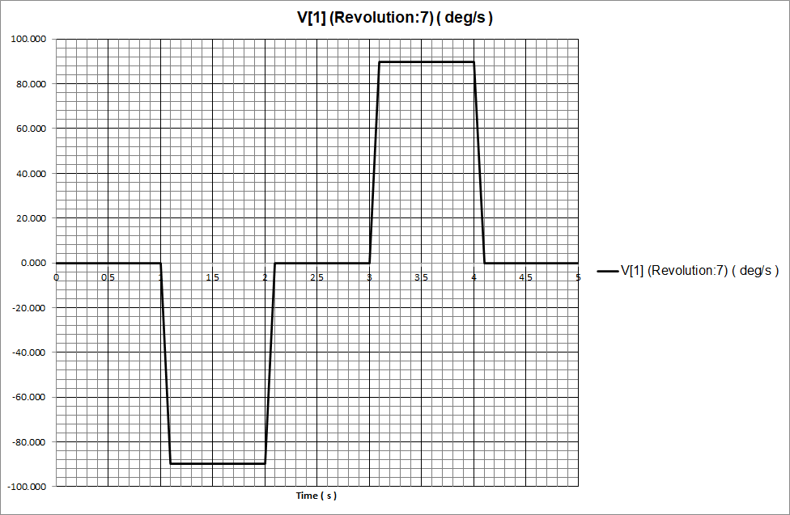

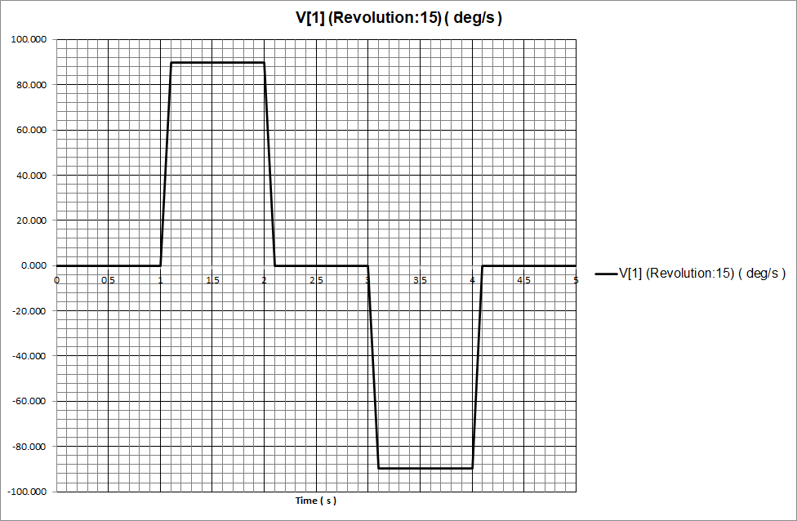

Fig. 7. Output Angular Velocity Graph of Gear G2

# 7. Challenges and Explanation of the Prototype Design

We met our biggest challenge right at the beginning of the design: we had no idea how many or what gears to use. Therefore, we arbitrarily set the general model to be of 3 pairs of 2 meshed gears connected axially with other pairs like a ladder. To get the optimum result, we computed using an enumeration method by a Python program, as shown in Fig. 11. We also assumed all modules to be the same to simplify the calculation.

Fig. 8. Preliminary Gear Ratio Calculation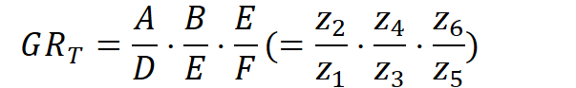

Fig. 9. Preliminary Simplified Gearing Mechanism Diagram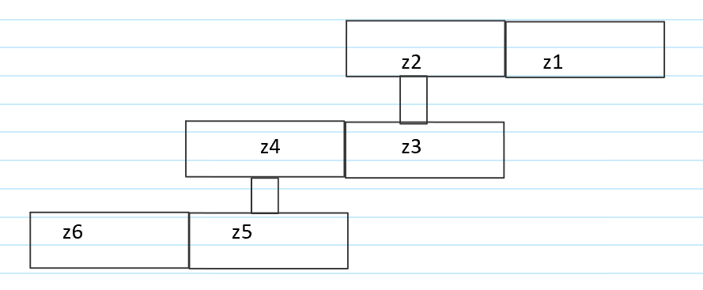

In the first part, z1, z2, z3, z4, z5, z6, and the uniform module, referred to Fig. 9, are marked as D, A, E, B, F, E, and n, respectively. To clarify, the inconvenience of naming convention exists because we didn’t notice it when we first made this script. The most important line in this part is “n=min(25/D,38.26/A,32.25/C,55/(C+math.ceil(F)),83/(D+A/2+E/2+B))” in Fig. 11, which returns the largest possible module under five dimensional constraints, as obtained in Fig. 10, where D1, D2, etc. are diameters of z1, z3, etc.. These constraints are added manually so that the gear train can fit into the prosthetic frame. The process of finding these constraints involves some painstaking inverse engineering and it will not be covered here.

Fig. 10. Dimensional Constraints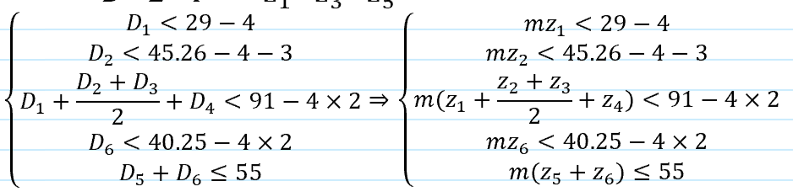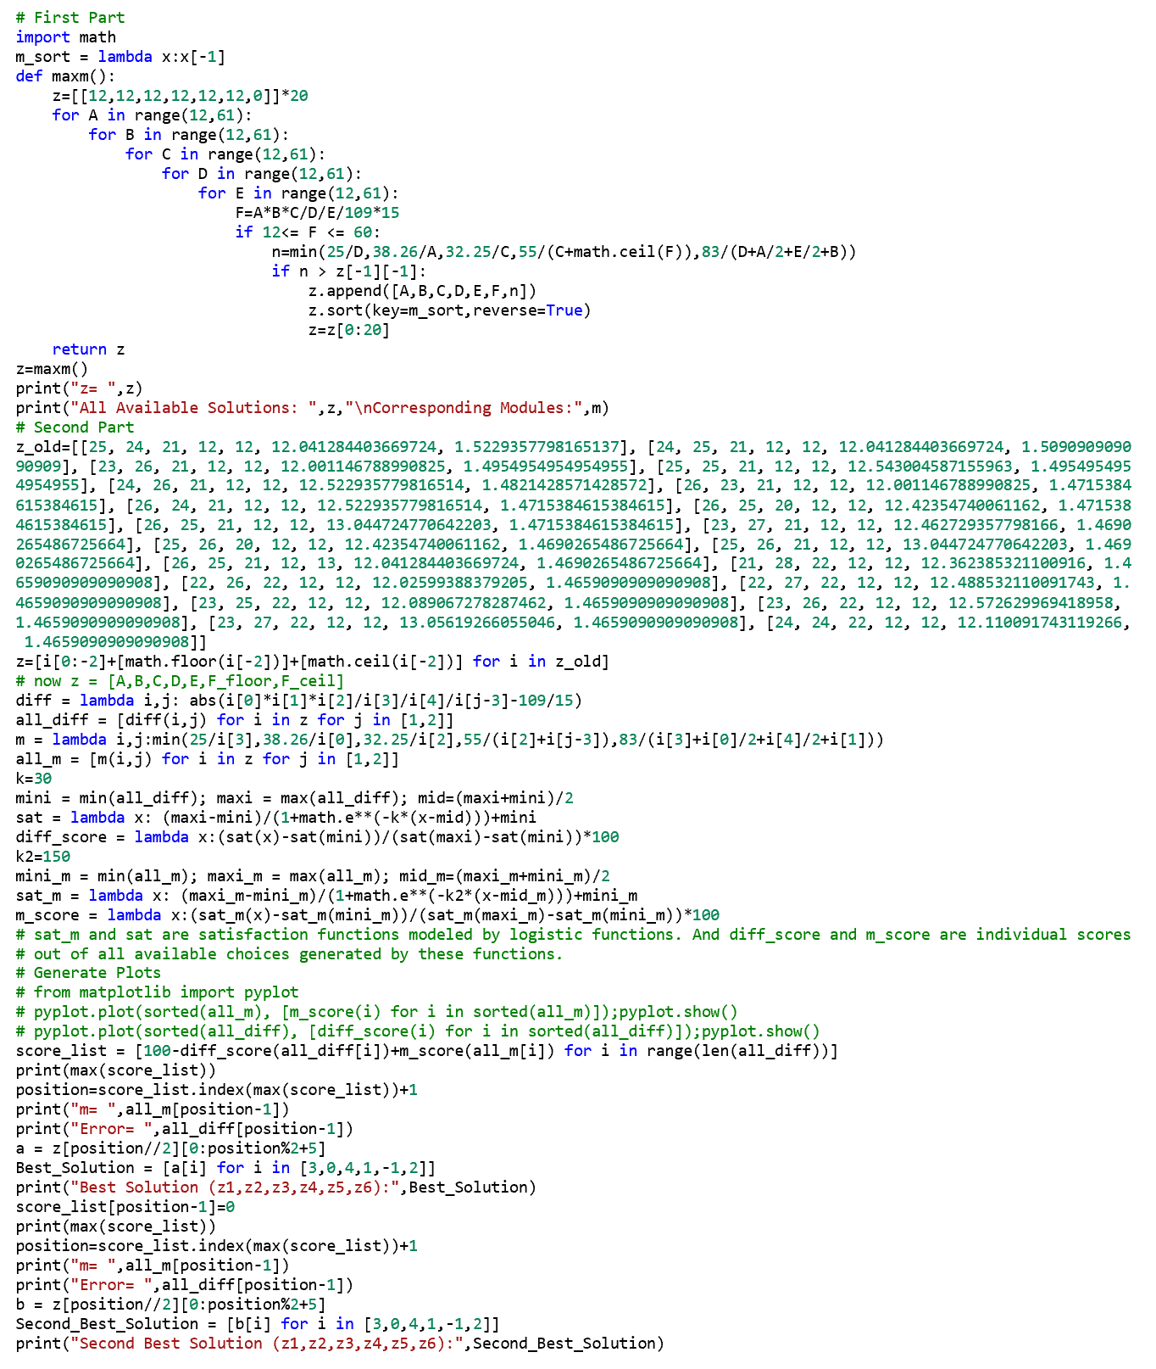

Fig. 11. Python Script for Gear Design

The general idea of the first part is to enumerate all combinations of numbers of teeth that satisfy the constraints and take out the first twenty sets that have the largest modules to carry on to the second part to optimize further by two satisfaction functions.

Moving to the second part, we generated two satisfaction functions in the form of S-shaped logistic functions that give scores, out of 100, to each set of gear parameters according to how big is the module and how accurate is the output speed, as results shown in Fig. 12(b). We then add the scores up and find the first two best solutions for our project. The trick needs to be pointed out is that “z_old” is the result of “z” obtained from the first part, whose processing time was too long that we ran each part separately.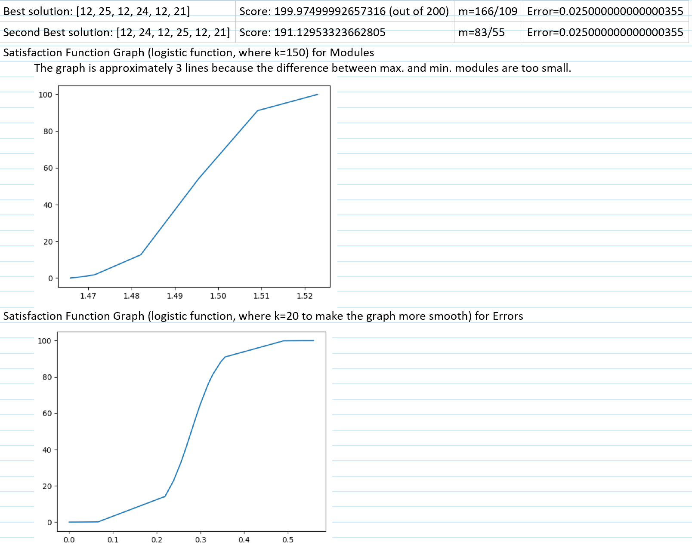

Fig. 12. Results from the Python Script. (a) Best and Second Best Solutions. (b) Satisfaction Function Graphs.

After we discovered the “best solution” for our gear parameters, we used gear F as a template to make gear G1 and G2 which represents index finger and thumb, respectively. We then added a new gear F, which has the same name but not the same parameters as the one mentioned above, in between gear E and gear G1, as illustrated in Fig. 2, inasmuch as we discovered that there was still some distance between them after we made the inventor model and the addition of a new gear in between does not affect the overall gear ratio. And of course, we reduced modules of gear A,B,C, and D to some small extent latter, so that the new gear F would perfectly fit into the design.

Challenges also come from some details. We were given a complicated prosthetic frame and it has two bridges on the top of it limiting the space for gears, especially the one right above the index finger, which made us spend several hours working out a proper size of gear F to put in. The gear F was either too big that its center axis extruded from the bottom of the frame or too small that it couldn't connect gear E with gear G1, as shown in Fig. 2.

# 8. Unique Features

The most important and unique parts of our design are the rigidly and beautifully connected mounting brackets, especially the hollowed-out “bracket 4”, referring to the title of a detail drawing attached below. The “bracket 4” not only tightens the connections between 4 rods, but also ensures the spacing between gear F and gear D without interfering gear E. We embossed our names onto this bracket to take credit for the success.

In addition, we made some dent features on some surfaces of mounting brackets for screw nuts to fit with less vertical loosening.

# 9. Answers to Group Discussion Questions

Q1:

Briefly explain your design decisions, outlining any unique decisions regarding gears or the support frame that had to be made, DFM/DFA considerations you took into account, and anything else you deem worthy of mention.

A:

Our primary decision is to arbitrarily construct a gear train model, find the best combination of numbers of teeth and module by a Python script, finally, make some adjustments to the modules while designing the new gear F, referred to Fig. 2, and mounting brackets.

Our design has many unique features. It has dent surfaces for screw nuts to fit, hollowed-out “bracket 4” for rod connections to be more rigid, and large face width of gears to prevent any relative misplacement of gears.

Considering DFM, we chose to use merely spur gears, to make production to be simple. Also, the large size of hole within “bracket 4” saves lots of material. Considering DFA, we combined bracket 1 and bracket 3 with two tubes, so that rods going through them will align more easily. The design of hollowed-out “bracket 4” helps that, as well.

Q2:

Does your design meet the design objectives? If so, briefly explain (with evidence) how you know this is the case. If not, briefly explain the particular challenges you faced that prevented you from achieving your design objectives.

A:

Yes, it does. According to the dynamic simulation graphs in Fig. 5, 6, and 7, the input gear and fingers rotate in the required speeds. Also, as illustrated in Fig. 4, fingers touch inside the functional workspace.

As shown in Fig. 3 and the Inventor file submitted through Avenue [1], all center axes of rods and gears are within the prosthetic frame, viewed from the side, and no part of the system is interfered by the prosthetic frame except the rods given, which is acceptable, so constraints are satisfied.

Q3:

What was the greatest design challenge you faced as a team when completing this project?

A:

The greatest challenge we faced was during the early stages of the project, where we had no idea what or how many gears to be used. In order to surpass this challenge,we arbitrarily set the general model to be of 3 pairs of 2 meshed gears connected axially with other pairs like a ladder. Not only did this decision give us a certain vision which we could either use or deny, it also allowed us to find the best solution mathematically, as computed by a Python program described in Fig. 11 using an enumeration method.

Q4: Provide at least two assumptions that were made of this project related to the prosthetic hand. Then, briefly describe how you might relax those assumptions to make your design more “realistic.”

A: We assumed that the weight and size of the implemented system are not within consideration. Realistically, our customer may want the prosthetic hand to be light and small in size, so we would choose to use materials with less smaller density and reduce modules of the gears to decrease their diameters.

# 

# 10. Summary of Individual Contributions

TABLE Ⅱ

SUMMARY OF INDIVIDUAL CONTRIBUTIONS

| Members/Contributions | Yuntian Wang | Vineeth Balachandran | Tianze Zhang | Jinnan Cheng |
| --- | --- | --- | --- | --- |
| Gear Parameters Design | Y(Yes) |  | Y | Y |
| Inventor Modelling of Gears | Y |  |  |  |
| Mounting Brackets Design | Y | Y | Y | Y |
| Inventor Modelling of Mounting Brackets | Y |  | Y |  |
| Dynamic Simulation |  | Y |  |  |
| Working Drawings |  |  |  | Y |
| 3D printing | Y | Y | Y | Y |
| Introduction in final report |  |  |  | Y |
| Create Gantt Chart |  | Y |  |  |
| Recording member attendance of meetings |  |  |  | Y |
| Answer group discussion questions |  | Y |  |  |
| Organization and Formatting of final report |  | Y |  |  |

# 11. Summary of Member Attendance

Everyone participated in all scheduled meetings as illustrated in the Gantt Chart shown below either face-to-face or electronically.

# 12. Gantt Chart

Fig. 13. Gantt Chart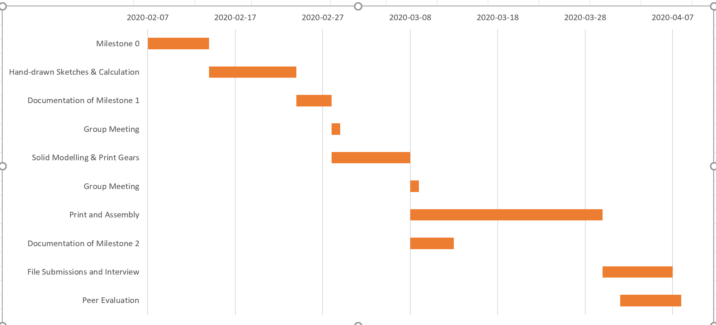

# 13. References

[1] Avenue.mcmaster.ca. 2020. *Avenue To Learn - Mcmaster University*. [online] Available at: https://avenue.mcmaster.ca/ [Accessed 2 April 2020].